Intro

The dataset used here comprises 517 of the 1,073 cows in the full study, representing those with complete records across all sensor variables. Cows with missing intake, activity, or environmental readings were excluded during preprocessing, potentially removing animals with more variable or extreme efficiency profiles.

I chose to use three models: Linear Regression, Random Forest, and XGBoost. Each produced a separate SHAP analysis, allowing me to cross-reference and check for inconsistencies across model analyses (e.g., the weight metric for EUE).

I validated each model using a 5-fold validation strategy
- The data was split into 5 groups and run 5 times, testing a different subsection of the data, then taking the mean r^2, standard deviation, min r^2, and max r^2.

The WUE and EUE models were primarily created for the SHAP Analysis to identify which biological and environmental factors drive variation in efficiency across animals. Since intake values are directly measured in this system, the predictions are redundant; the metrics can be computed from their formulas.

The water intake models were created to predict and compare the MAE between my models and the Murphy equation.
- The Murphy equation is a 1983 regression equation built on population averages, not individual sensor data.
- This equation predicts water intake (L/day).

Dataset analysis
The dataset has ~8500 rows; my preprocessing reduced it to 2677.
- Initially, I trained the model on a total of 2677 samples. With this data, the XGBoost model performed the best.
  - This was likely due to a larger sample size and the model recognizing individual cows from the testing set. (Leakage)
- I then removed duplicate cows and ensured the test set contained unique cows that didn’t appear in the training set. This cut down the sample size to 517.
- This led to a significant decrease in performance across all models, with all of them performing similarly to each other
  - This can be attributed to a smaller sample size (413 for training, 104 for testing) and the fact that the model cannot rely solely on data recognition; it must predict new cow outputs.

My models had r^2 values ranging from .34 to .44, explaining 34-44% of the variance. The remaining 56-66% can be attributed to variables not in the dataset, such as genetics, feed quality variation, rumen microbiome, and individual cow temperament.

Leakage
The current data output ensures no data leakage.
- Leakage occurs when the model sees the same data point in both training and testing, allowing it to predict with greater accuracy (because the "prediction" becomes recognition).
- This was changed because recognizing cows enables the model to find metrics specific to each cow, which harms the generalizability of the SHAP explanations.

Finding #1
Moreover, EUE does not directly use data from the ‘NE for lactation from feed’ column, as this EUE is mechanically dependent on this metric.
- This improves the SHAP analysis, removing any circular logic, and yields these: 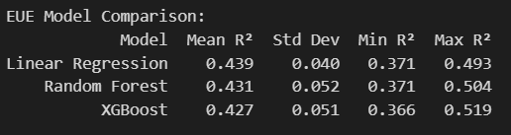

WUE:
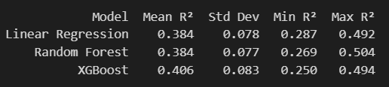
However, removing the data from the ‘water_intake_liter_y’ column yields a minimum, negative r^2 value for XGBoost and RF models when trying to predict WUE:
Model Mean R² Std Dev Min R² Max R²
Linear Regression 0.123 0.056 0.062 0.213
Random Forest 0.145 0.086 -0.007 0.255
XGBoost 0.069 0.107 -0.126 0.196

This is a key finding:
A negative R² indicates that the model performs worse than a random-prediction baseline, confirming that water intake is not just correlated with WUE but is mechanistically indispensable to it. This is consistent with the WEF nexus framework: water and food (milk) production cannot be separated at the individual cow level.

Key question: How can EUE effectively predict milk production without using its mechanically dependent variable, but WUE can’t?

Answer: NE for lactation from food intake can be predicted using other metrics such as DIM, DMI, and weight. Water intake, however, cannot be predicted well from other metrics. This is exactly why Murphy’s equation fails to predict water intake, and my model is unable to predict milk production without water intake data.

This finding also explains some of the variation in the model’s accuracy:
- There is a strong correlation among the metrics in this data: DMI, DIM, Weight, and Net energy are all highly correlated. This harms XGBoost’s performance significantly, as the model architecture revolves around sequential improvement
- On the other hand, Random Forest builds trees in parallel, so while some trees may overfit due to correlation, the average across trees improves accuracy.

WUE SHAP Analysis
Across all models, water intake, net energy, and DIM have the largest effect on WUE. Water intake mechanically lowers WUE, with the largest effect in the RF and XGB analyses, while NE has the largest effect in the LR analysis.
- This can be explained by the architecture of an LR model: the model is picking up the correlation between NE and milk production, and since WUE = Milk Production / Water intake, the LR model is essentially predicting milk production rather than water efficiency.
- This also explains the weight on NE in the LR model compared to the other two models.
- This equation also explains why increased water intake lowers WUE.
All models attribute higher DIM to lower efficiency, which makes biological sense: late-lactation cows are less efficient.
DMI varies across the three models, with LR ranking it last, RF ranking it in the middle, and XGB ranking it highest. In the XGB model, there is a mixed color spread, indicating that DMI is not a direct driver of WUE.
- A high DMI can push WUE both ways:
  - A high-DMI cow with high milk production likely drinks more water, increasing both variables that affect WUE. This alone can cause significant variance in this metric.
- The LR model sees this bi-directional effect, and the metric is effectively canceled out, giving it the least importance on the SHAP analysis.
Weight is inconsistent between models, with LR ranking it #4 and XGB ranking it #10.
- Biologically, weight is a critical metric for determining water efficiency, as reflected in the LR model.
- Due to the direct correlation between weight and DMI, feature similarity led the XGB model to substitute weights for similar features while building trees, thereby limiting the metric's output importance.
- The linear model could represent the contributions of weights independently because it estimates all the coefficients simultaneously rather than sequentially.
  - Since weight is highly correlated with other metrics, XGBoost will split on whichever metric minimizes prediction error. Other metrics, such as DMI, have a more overall effect on milk production, so they will consistently be favored for each tree.
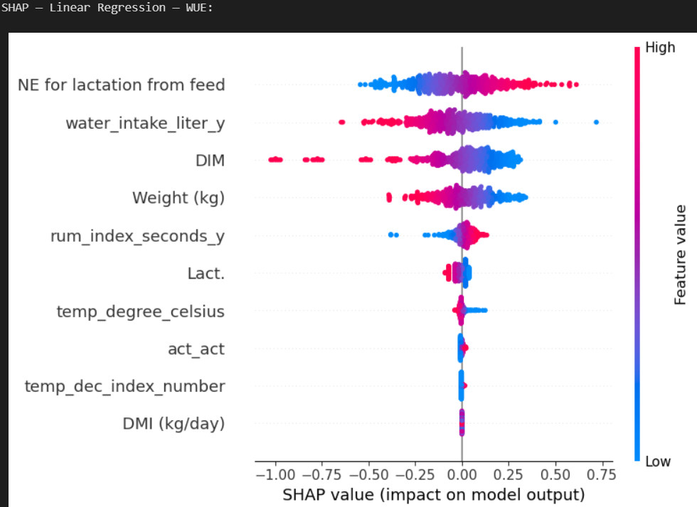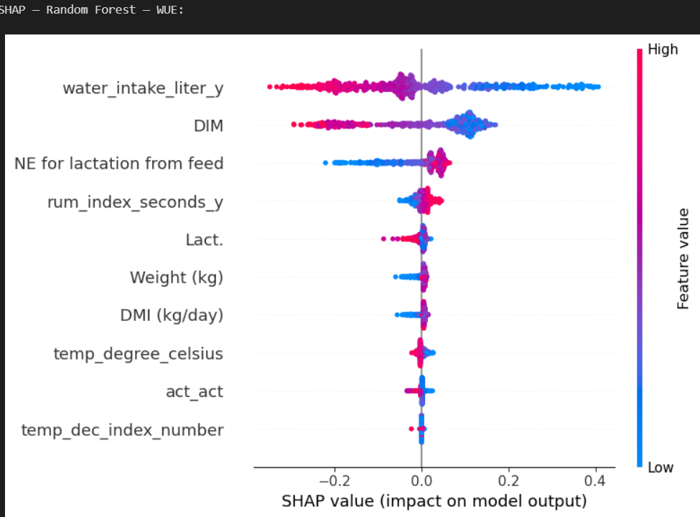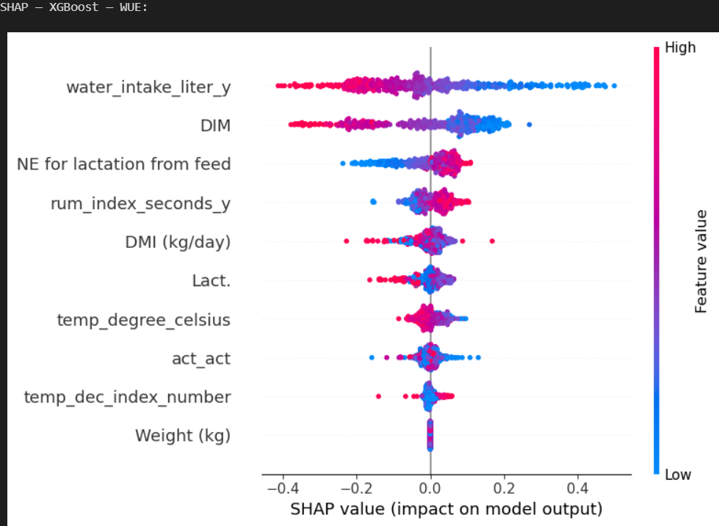

EUE SHAP Analysis
Across all three models, DIM has the largest effect on EUE: the more days in milk a cow spends, the less efficient it becomes.
- The LR model significantly overestimates its effect, as the SHAP value extends to -2.0 for it. This can be attributed to the simple model architecture: an LR model cannot accurately represent the curvilinear nature of this dataset, and therefore attributes the effects of many other factors to DIM.
DMI (dry matter intake) is slightly inconsistent across models, as the LR model ranks it last, while RF and XGB rank it high.
- Both tree models predict that increased DMI can lower energy efficiency, but some high-DMI observations push positive
  - This makes biological sense: many cows may consume excess feed relative to their milk production, resulting in a low EUE, while some cows may consume large amounts of feed and still produce enough milk to maintain a high EUE, resulting in a positive SHAP contribution.
- The LR model likely suppressed the effects of DMI because it was highly correlated with the NE for lactation from feed value, leading to the inaccuracy.
- Energy efficiency was also calculated by (milk produced / NE for lactation), creating a strong dependence on that variable.
Weight is inconsistent between models, with LR ranking it #2 and XGB ranking it #10.
- Biologically, weight is a critical metric for determining energy efficiency, as reflected in the LR model.
- Due to the direct correlation among weights, DMI, and water intake, feature similarity led the XGB model to substitute weights for similar features while building trees, thereby limiting the metric's output importance.
- The linear model could represent the contributions of weights independently because it estimates all the coefficients simultaneously rather than sequentially.
  - Since weight is highly correlated with other metrics, XGBoost will split on whichever metric minimizes prediction error. Other metrics, such as DMI, have a more overall effect on milk production, so they will consistently be favored for each tree.

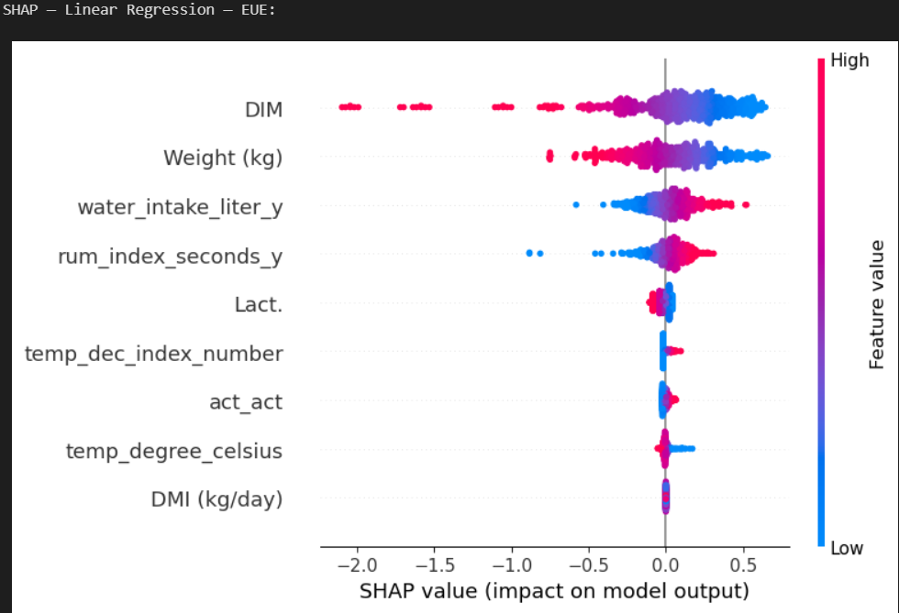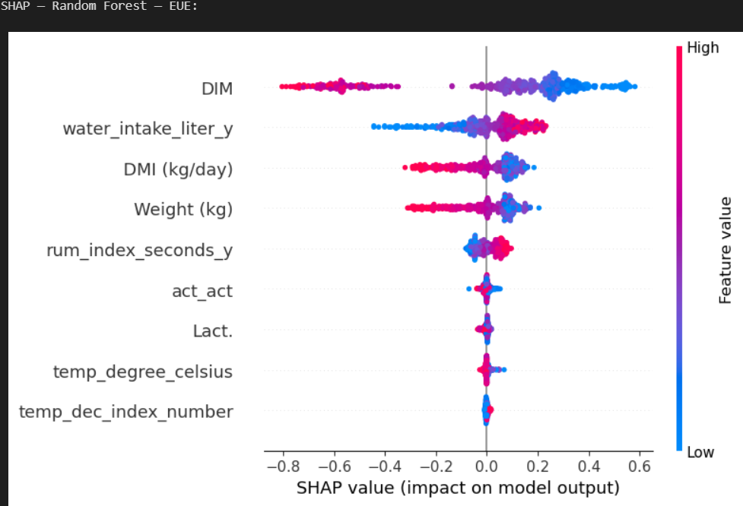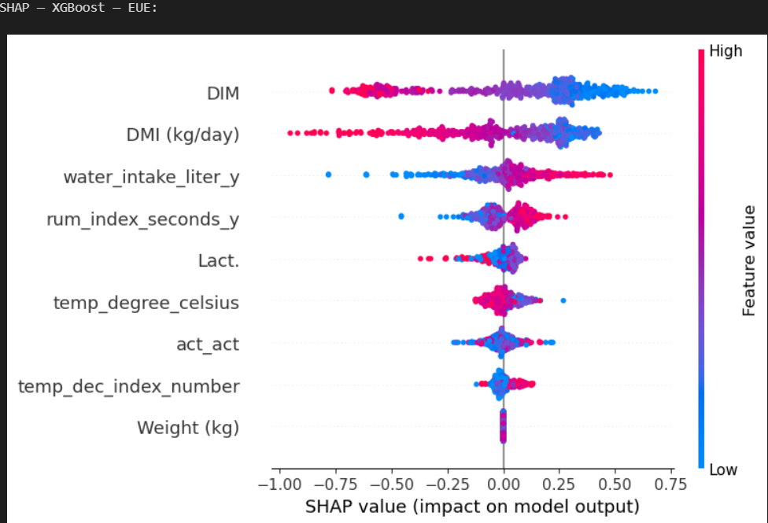

Water Intake
Water intake has the opposite effect on EUE as it did on WUE; increased water intake now INCREASES overall energy efficiency.
- This shows that high water intake is a sign of high-producing, energy-efficient cows. This high water intake mechanically lowers WUE, but the high milk production dominates both metrics (EUE and WUE).
- While the abstract reports R²=0.67 between WUE and EUE across 1,073 cows, this dataset of 517 unique cows yields R²=0.271 at the cow level. This suggests a weaker but still statistically significant correlation (p<0.0001).
All three models achieved lower MAE on water intake prediction than the Murphy equation baseline (22.09 L/day), with improvements ranging from 6.34 to 7.07 L/day.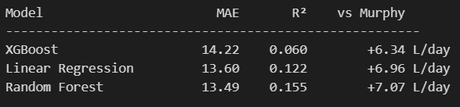

Next steps + current limitations
- Tuning the training variables will improve the overall model; this should be relatively simple.
- Learn more about the variance in r^2 across my models and the abstract, specifically the near-zero values for water intake.
  - Check on the .271 vs the abstract’s .67 r^2 value; do this by checking if the 517 subset is different from the 1073 subset.
- Calculate residual plots for all models, and also compare residuals with Murphy’s -10.59 L/day.
- Add a section on practical implications from this data
  - For now, this focuses primarily on the need for water sensors in this field.
- Add a 3-day rolling average of DMI water intake; this will use more of the dataset and will eventually lead to the development of an LSTM model.
  - This is mostly why temperature is showing such low importance; each data point is an instant snapshot. Adding this rolling average for each cow (to the extent the data allows) will improve SHAP interpretation.
What I learned
Machine learning:
- Linear regression, random forests, and XGBoost model architectures.
  - XGB underperformed expectations due to variable correlation; the model gets “confused” and will always split at the point of maximum gain. In context, this was at DMI, not weight, hence the underestimation in both SHAP Analysis.
    - Gain = the reduction in loss of a given split
      - A split is when a tree branches.
  - LR estimates the coefficients of each feature simultaneously, so the feature weights are independent of those in DMI, and LR may yield the most accurate importance weights in the SHAP analysis.
  - RF adjusted for correlated features through its parallel tree structure, averaging across all trees.
- SHAP Analysis
Statistics:
- R^2 meaning in context
- Standard deviation in context

